**HL Unit 7** **– Control**  
Quiz 1

|  |  |  |  |
| --- | --- | --- | --- |
| **Question 1** | | | |
| Objectives: | 7.1.8 | Exam Reference: | May-14 10 |

1. Outline **two** distinct features of autonomous agents. [4]

|  |  |  |  |
| --- | --- | --- | --- |
| **Question 2** | | | |
| Objectives: | 7.1.1, 7.1.3,7.1.4, 7.1.7 | Exam Reference: | Nov-14 15 |

1. A company uses computer controlled equipment to monitor and control a heating system. The user controls the system via an on/off switch and two dials that are used to set the maximum and minimum temperatures desired.

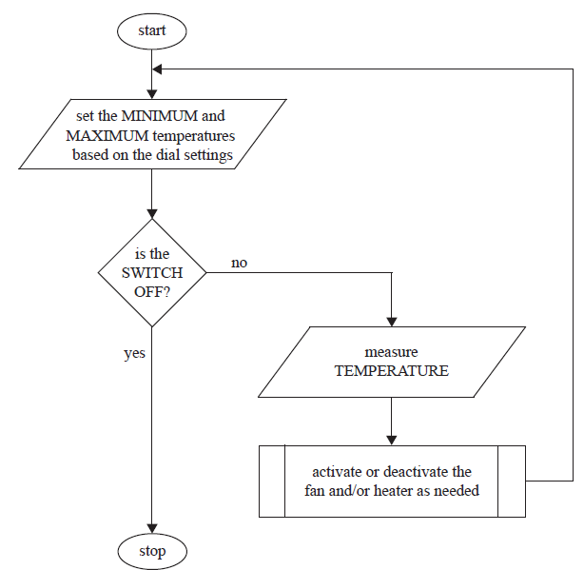The following flowchart represents the algorithm used to control temperature.

The temperature is constantly measured and the process of making the decision on   
which action to take is as follows.

If it is too cold (temperature is less than the minimum) then the heater should be  
switched on. If it is too hot (temperature is greater than the maximum) then the   
fan should be switched on. If temperature is within the given range (temperature  
greater than the minimum and less than the maximum) then both the fan and heater  
should be switched off.

1. Identify **one** situation in which the system should respond to
2. input from a user; [1]

1. temperature. [1]

1. State three hardware devices that are needed to capture the input data and   
   produce the system outputs. [3]

1. Construct pseudocode for the algorithm outlined on the previous page. [4]

1. The company wants to use its heating system to control the temperature of ten   
   different places at the same time. All ten places will have the same maximum and  
   minimum temperatures and each will have its own heater, fan, and temperature  
   sensor. Evaluate the decision of having all ten temperature sensors, fans, and heaters  
   connected to a single control computer instead of having ten separate heating systems. [6]

|  |  |  |  |
| --- | --- | --- | --- |
| **Question 3** | | | |
| Objectives: | 7.1.1, 7.1.2, 7.1.3 | Exam Reference: | May-14 11 |

A builder is renovating a series of apartments and is considering integrating a few electrical  
devices in each apartment into an automatic programmable system. One example is the  
integration of lighting, heating, ventilation and air conditioning.

1. Identify **two** groups of users that might find this integrated technology

particularly appealing. [2]

1. Discuss **two** advantages, offered by this technology, that could be used in an advertisement for the apartments. [4]

1. Evaluate **two** ways users can access the functionality of the integrated system   
   at home. [6]

The same technology is adapted and used for intensive chicken farming; in this context a  
 decentralized control is preferred.

1. Describe how this could be achieved. [3]